player (player_id, pname,speciality,date_of joining,num_matches,team_id) team(team_id, tname,player_num) matches(match_id, team1_id,team2_id,match_date,winner,man_of_the match) simple query

1. display all players playerid, player name and experience

🡪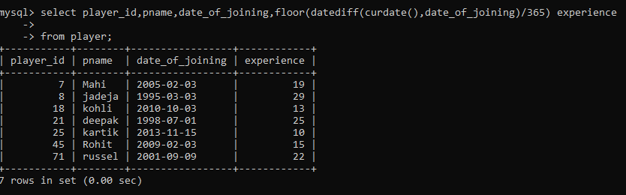

1. display all player with experience > 5 years

🡪

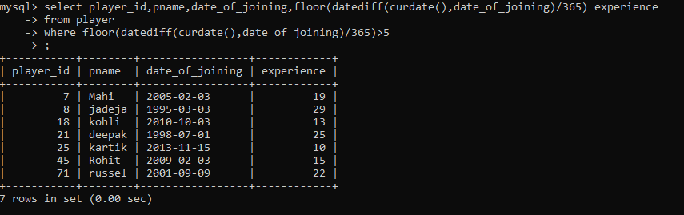

1. display all players joined in march month, any year

🡪

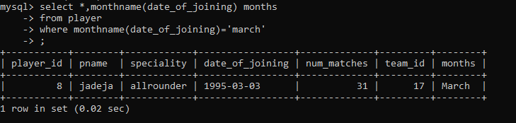

1. display all players joined in march 1995

🡪

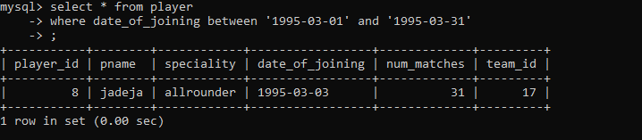

1. display all player with number of matches played are either 5 or 10 or 8

🡪

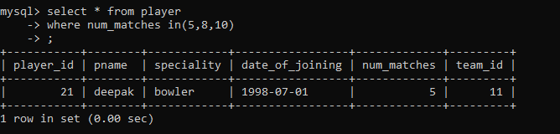

1. display all players who are either batsman, bowler

🡪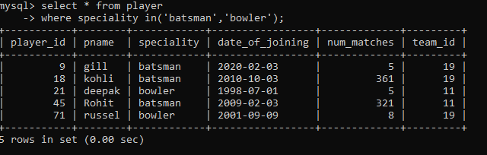

1. 7. display all players who joined in year 1995 or 1996 or 1997

🡪

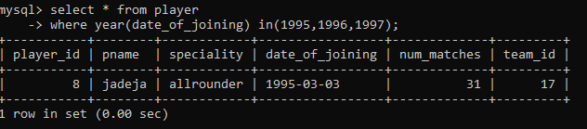

Nested query

1. list all player who plays in virat kohalis team

🡪

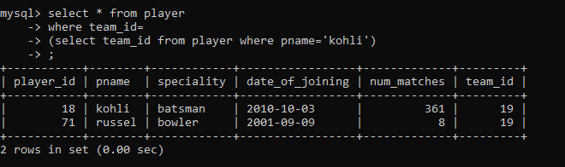

1. list all players who played matches in year 2024

🡪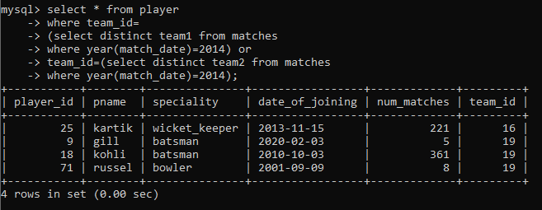

1. list all matches in which man of the match is from team1

🡪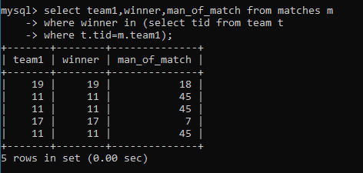

1. list all matches in which man of the match is from team1

🡪



1. list all matches in which csk team win.

🡪

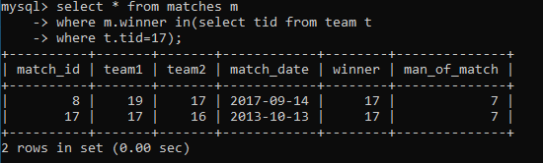

1. list all matches in which either csk or rcb team won the match ;

🡪

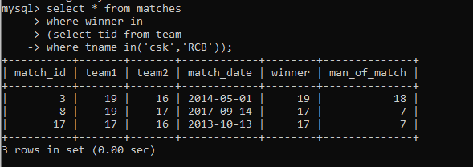

1. list all teams who one atleast one match

🡪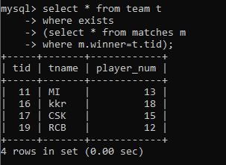

1. list all teams who does not played any match

🡪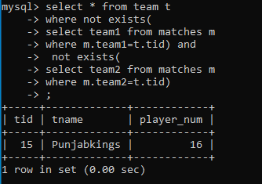

1. list all team name, in which no players are their

🡪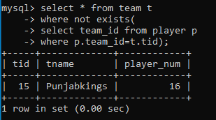

1. list all players who are in dhoni’s team

🡪

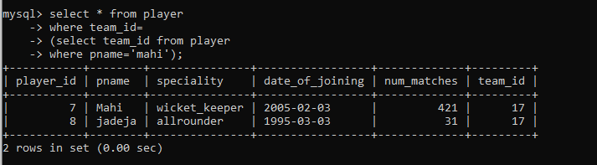

1. list all players who are in either dhoni’s or virat’s team

🡪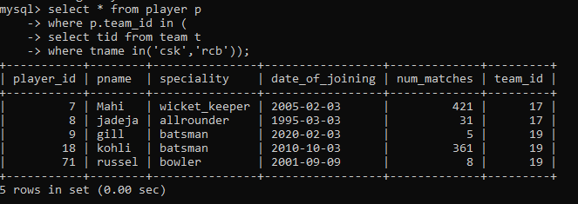

1. find all team names who one more than 3 matches

🡪

